Experiment No.: Date:

Title: :Exploring HTTP,TCP and UDP using wireshark
Learning Objectives: At the end of this experiment, students will be able to:
- Perform experiments in WIRESHARK-Packet analyzer software
- Extract TCP and UDP header details , HTTP message formats and IPV4 datagram.
- Analyze cookies and forms
Pre-requisite : Basic concepts of HTTP, TCP and UDP
Apparatus : Wireshark

Theory:
Wireshark is a network packet analyzer. A network packet analyzer will try to capture network packets and tries to display that packet data as detailed as possible. You could think of a network packet analyzer as a measuring device used to examine what’s going on inside a network cable, just like a voltmeter is used by an electrician to examine what’s going on inside an electric cable (but at a higher level, of course).In the past, such tools were either very expensive, proprietary, or both. However, with the advent of Wireshark, all that has changed. Wireshark is perhaps one of the best open source packet analyzers available today.
Some intended purposes of wireshark
- Network administrators use it to troubleshoot network problems.
- Network security engineers use it to examine security problems.
- Developers use it to debug protocol implementations.
- People use it to learn network protocol internals.
Features:
- Available for UNIX and Windows.
- Capture live packet data from a network interface.
- Open files containing packet data captured with tcpdump/WinDump, Wireshark, and a number of other packet capture programs.
- Import packets from text files containing hex dumps of packet data.
- Display packets with very detailed protocol information.
- Save packet data captured.
- Export some or all packets in a number of capture file formats.
- Filter packets on many criteria.
- Search for packets on many criteria.
- Colorize packet display based on filters.
- Create various statistics.
Data packets in TCP/IP protocol suite
The packet is the basic unit of information transferred across a network, consisting, at a minimum, of a header with the sending and receiving hosts' addresses, and a body with the data to be transferred. As the packet travels through the TCP/IP protocol stack, the protocols at each layer either add or remove fields from the basic header. When a protocol on the sending host adds data to the packet header, the process is called data encapsulation. Moreover, each layer has a different term for the altered packet as shown in figure.
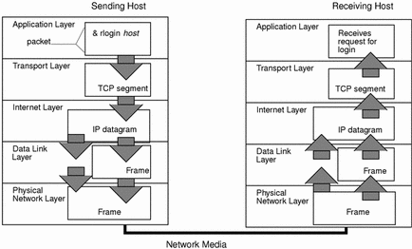
By using wireshark , we can extract the details encapsulated by each layer within the packet.

- Application layer
The packet's history begins when a user on one system sends a message or issues a command that must access a remote system. The application protocol formats the packet so that the appropriate transport layer protocol, TCP or UDP, can handle the packet. One of the application layer protocol used for web browsing is HTTP(Hyper text transfer protocol). HTTP provides 2 types messages, Request message and Response message. The packet moves from browser to server contains request message. Wireshark can extract request message format from the packets. One example of request message is
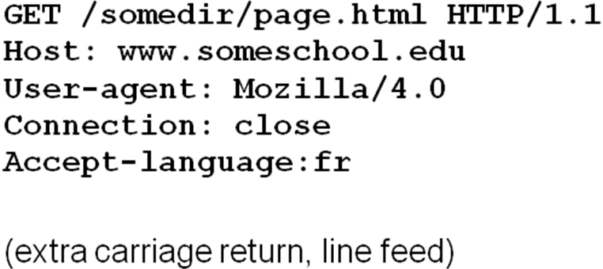
If a packet moves from server to browser, then it contains response message. One example of response message is
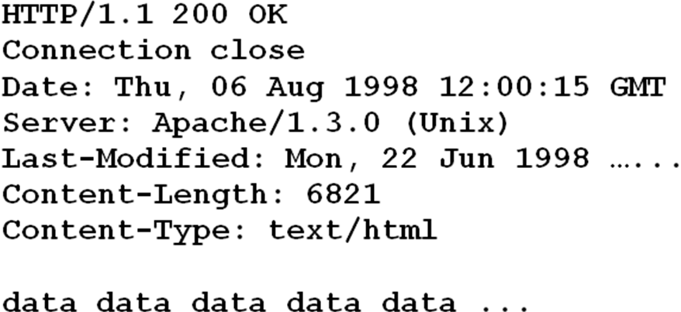
- Transport Layer
The packet's history begins when a user on one system sends a message or issues a command that must access a remote system. The application protocol formats the packet so that the appropriate transport layer protocol, TCP or UDP, can handle the packet.
If a packet follows TCP, then it carries a particular header format as given below.
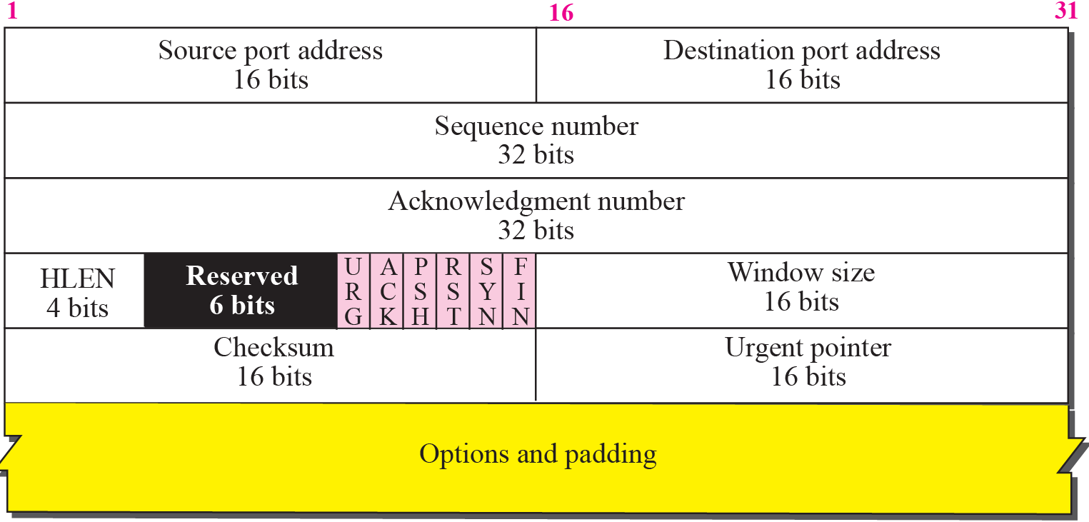
If a packet follows UDP, then it carries a particular header format as given below.
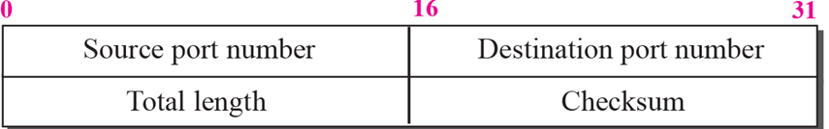

TCP is often called a “connection-oriented” protocol because TCP ensures the successful delivery of data to the receiving host. TCP then divides the data that is received from the application layer into segments and attaches a header to each segment. Segment headers contain sending and receiving ports, segment ordering information, and a data field that is known as a checksum. The TCP protocols on both hosts use the checksum data to determine if the data transfers without error.
UDP is a “connectionless” protocol. Unlike TCP, UDP does not check that data arrived at the receiving host. Instead, UDP formats the message that is received from the application layer into UDP packets. UDP attaches a header to each packet. The header contains the sending and receiving ports, a field with the length of the packet, and a checksum. The sending UDP process attempts to send the packet to its peer UDP process on the receiving host. The application layer determines whether the receiving UDP process acknowledges the reception of the packet. UDP requires no notification of receipt. UDP does not use the three-way handshake.
- Internet Layer
The transport protocols TCP, UDP pass their segments and packets down to the Internet layer, where the IP protocol handles the segments and packets. IP prepares them for delivery by formatting them into units called IP data grams. IP then determines the IP addresses for the data grams, so that they can be delivered effectively to the receiving host. IP attaches an IP header to the segment or packet's header, in addition to the information that is added by TCP or UDP. Information in the IP header includes the IP addresses of the sending and receiving hosts, the datagram length, and the datagram sequence order. This information is provided if the datagram exceeds the allowable byte size for network packets and must be fragmented. The IPV4 datagram format is shown below.
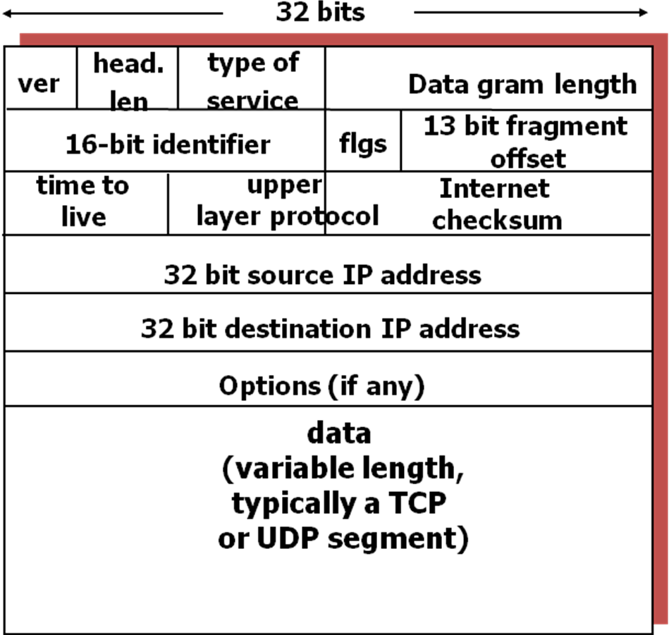

HTTP cookies
HTTP cookies provide the server with a mechanism to store and retrieve state information on the client application's system. This mechanism allows web-based applications the ability to store information about selected items, user preferences, registration information, and other information that can be retrieved later. There are two headers, Set-Cookie and Cookie, that are related to cookies. The Set-Cookie header is sent by the server in response to an HTTP request, which is used to create a cookie on the user's system. The Cookie header is included by the client application with an HTTP request sent to a server, if there is a cookie that has a matching domain and path.
HTTP Forms
A webform or HTML form on a web page allows a user to enter data that is sent to a server for processing. Forms can resemble paper or database forms because web users fill out the forms using checkboxes, radio buttons, or text fields. For example, forms can be used to enter shipping or credit card data to order a product, or can be used to retrieve search results from a search engine.
Procedure
1. Enter name of any website in the user agent of your computer.
2. Open wireshark. Click on capture.
3. Click on interface. Select the name of the interface which provides internet in your system.
4. Click on start. Now wireshark will display the whole packets travel from user agent to that particular site and vice versa.
5. Filter the packets. For that, use key words http, tcp and udp to get the corresponding packets. Select one packet and observe the each layer information.
6. To explore http cookie, go to user agent and type the web page name http.recipes.com/1/2/cookies.php.
7. Repeat 2,3,4 steps
8.Go to that particular web page again and enter a name in set cookie header.
9.Go to wireshark. Filter http packets. Select packet with method name post and click on html url. Now observe the cookie name here.
10. To explore http forms, go to user agent and type the web page name http.recipes.com/1/2/forms.php.
11.Repeat the step 7
12. Go to that particular web page again and enter user id and password .
13. Go to wireshark. Filter http packets. Select packet with method name post and click on html url. Now observe user id and password here.
14. To get more details, click on analyse and click on follow tcp stream.
Result and Discussion:

Conclusion:

